Palestine's elections: Why they matter
By Osayd Awawda
Assistant Professor of Constitutional Law, Hebron University
15 Apr 2021
Last February, President Mahmoud Abbas (Abu Mazen), issued a decree-by-law, declaring that parliamentary elections will take place on 22 May, and presidential elections on 24 July of this year.
This declaration comes after fifteen years of living under an emergency regime in the West Bank, which started in July 2007, when Fatah, the losing party in 2006 parliamentary elections, refused to make a peaceful transition of power to the winning party of Hamas. Since that year, Hamas has been ruling Gaza and Fatah has been ruling the West Bank through their own respective governments.
Suddenly, Abbas decided to hold the elections. There are two explanations for "why now?" that Palestinian analysts propose.
The first explanation is that Joe Biden has forced Abbas to do so if the latter wants US financial support to continue, arguing that Biden sees it as improper to support an authoritarian regime. The second explanation is that Abbas fears for his potential successors, and since he deems his days to be numbered given his health condition, he wants to make sure that no ruthless rivalry will burst once he travels to the final abode.
Both explanations hold water. It is vital, too, to highlight that the worsening of the economic conditions in Palestine, caused mainly by the government’s failure to respond to the coronavirus pandemic in the West Bank, has pushed Abbas and his clique to escape public disdain via calling for elections.
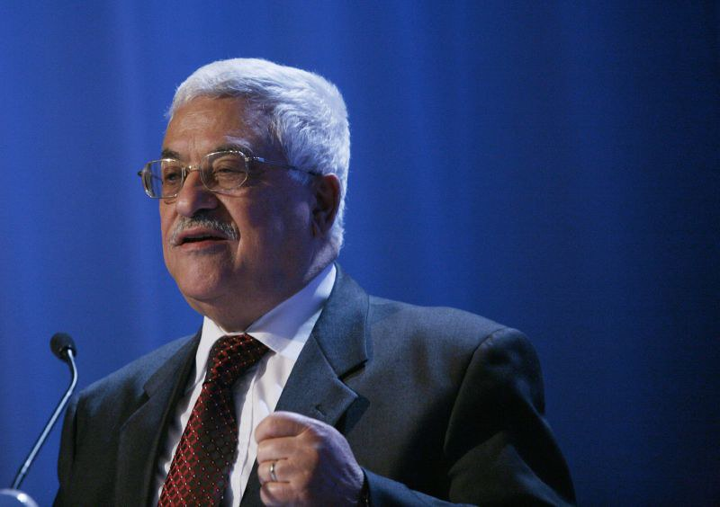Mahmoud Abbas's ailing health means he may not be on the political scene much longer. Pic: World Economic Forum/Flickr

Do the elections matter?
Yes, a lot. This is because whatever the outcome of the elections might be, it will bring an end to the authoritarian, emergency regime that has darkened the public life of Palestinians for the last fifteen years, and caused the establishment of a deep structure of corruption in all of Palestine.
Palestinians are facing three existential challenges in terms of their dealing with the Israeli occupation.
First, the issue of Jerusalem, which the International Criminal Court has recently declared its eastern province to be part of Palestine. Second, the issue of refugees, and their right of return. Third, the right to self-determination through military resistance against the Israeli occupation, especially after the recent ruling by that court to open an investigation of war crimes in Palestine conducted by Israeli forces.
All these problems need a firm response by a truly representative body of the Palestinians - namely a parliament.

What’s likely to be the result?
Importantly, Abbas, though a decree-by-law, amended the elections law of 2007, and removed the right to independently run for parliamentary elections. Only electoral lists can run, with the minimum of 16 individuals and the maximum of 132. The nomination period ended last week.
Now, there are 36 electoral lists running to get the votes of 2,560,000 registered electors in Palestine.
Hamas has one list, named "Jerusalem is our promised meeting place". However, Fatah, seriously fragmented, is running with three lists. One is official, while the other two are considered "apostates" by Fatah officials.
The first group of "apostates" are those running under Nasir Al-Qudoah list, who is the faithful friend of Marwan Al-Barghouthi, a Fatah figure that represents those who believe in resistance rather than negotiations with the Israeli occupation.
The other group of "apostates" are those running under Samir Al-Mash'harawi, the faithful friend of Abbas' archaic enemy: Muhammad Dahlan. Dahlan, described by George W Bush as "smart boy" is currently the advisor of international security of the UAE's leader Muhammad bin Zaid.
It is well known that Dahlan is a very good 'collaborator' in the eyes of the Israelis, given the recent normalisation of relations between the UAE and the Israeli authorities. These are 4 of the 36 electoral lists. Two of the remaining are represent the left parties in Palestine, while almost all of the other 34 lists are independent persons.
It is hard to expect the results, because there has been no data to test the political views of the majority of electors so far. Nevertheless, after the elections' campaign starts at the end of this month, there will be lots of expressions of political view to form row data that analysts might rely on to expect the outcome of the elections.
However, those claiming powerful insights believe that Hamas with have between 25 to 35 seats, Abbas' Fatah will have 20 to 25, Dahlan's Fatah will have 15-20, Bargouthi's Fatah will have 10-25, and the rest will be distributed on five of the other lists, while the rest will not reach the winning threshold of 1.5 per cent of valid votes.
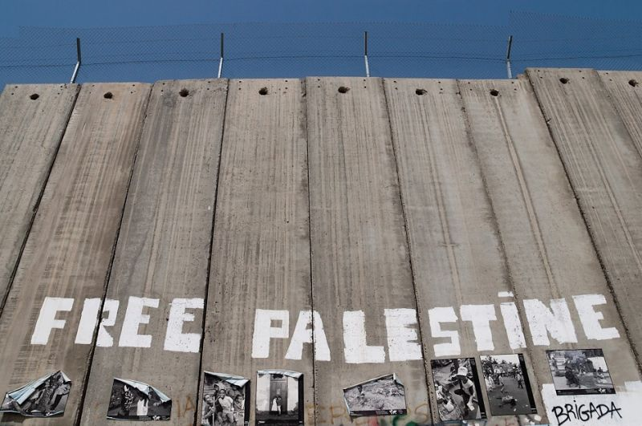Pic: Montecruz Foto/ Flickr

What are the implications for the Arab-Israeli conflict?
If Hamas secures a majority, and succeeds to establish collisions to get more than half of the parliament, then its list's name ("Jerusalem is our promised meeting place") tells you what the implication will be in the Palestinians struggle against the Israeli occupation.
The other opposite on the spectrum is Dahlan's Fatah, and if his list gets a majority and secures substantial collisions in the parliament, then the implication would be a normalisation of relations with the Israeli occupation. For the other lists, there are different views on what the implication would be, ranging from that of Hamas' victory to that of Dahlan's victory.
Whoever the winner might be, we must not forget that given Israeli forces arrested the majority of parliamentarians in 2006, they can do the same to the winners in 2021 should they wish to do so.
Which brings the fundamental question back to the fore: can there be an effective parliament under occupation? Only God knows, and time will tell.
Osayd Awawda is an Assistant Professor of Constitutional Law at Hebron University, Palestine. He teaches Public International Law, International Humanitarian Law, International Criminal Law, and Research Methods. He holds an LLB from Birzeit University, an LLM and a PhD from Melbourne Law School, Australia. His PhD thesis’ title was: “The Palestinian Supreme Constitutional Court: A Critical Assessment of its Independence under the Emergency Regime of the West Bank”. He participated in multiple conferences and published several papers that discussed legal challenges present in Palestine in various fields including tax law, labour law, international humanitarian law, and trade law.

